EXPERIMENT 5
DATA VISUALIZATION USING MATPLOTLIB – FIFA WORLD CUP 2026 PLAYER PERFORMANCE
Aim
To create and analyze data visualizations such as horizontal bar charts, line charts, pie charts, histograms, and scatter plots using Matplotlib for effective interpretation of the FIFA World Cup 2026 player performance dataset.
Algorithm 1 – Horizontal Bar Chart
Step 1: Import Pandas, NumPy, and Matplotlib libraries and load the FIFA player performance dataset.
Step 2: Group the data by player_name and calculate the total goals scored by each player.
Step 3: Select the top 10 players based on total goals and sort the values.
Step 4: Create a horizontal bar chart using the barh() function.
Step 5: Add the chart title, X-axis label, Y-axis label, and display the chart.
Program 1:
import pandas as pd
import numpy as np
import matplotlib.pyplot as plt
df=pd.read_csv("../../data/fifa_world_cup_2026_player_performance.csv"); print("Dataset loaded successfully"); print("Shape:",df.shape); display(df.head())
Output:
A horizontal bar chart titled “Top 10 Players – Goals” displaying the top ten players according to their total goals.
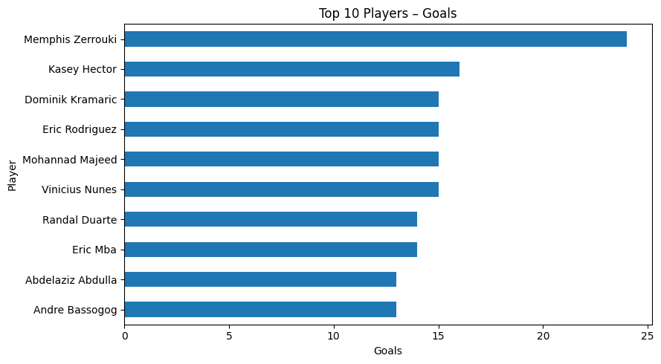
Interpretation:
The chart compares the goal contributions of the top ten players. The longest bar represents the highest total goals among the selected players.
Algorithm 2 – Line Chart
Step 1: Group the data by team and calculate the total goals scored by each team.
Step 2: Select the top 15 teams according to total goals.
Step 3: Plot the team names and total goals using the plot() function with markers.
Step 4: Add a title, axis labels, rotated team labels, and grid lines.
Step 5: Display the line chart.
Program 3:
plt.figure(figsize=(9,5)); player_goals.plot(kind="barh"); plt.title("Top 10 Players – Goals"); plt.xlabel("Goals"); plt.ylabel("Player"); plt.tight_layout(); plt.show()
Output:
A line chart titled “Top 15 Teams by Total Goals” showing total goals scored by the selected teams.
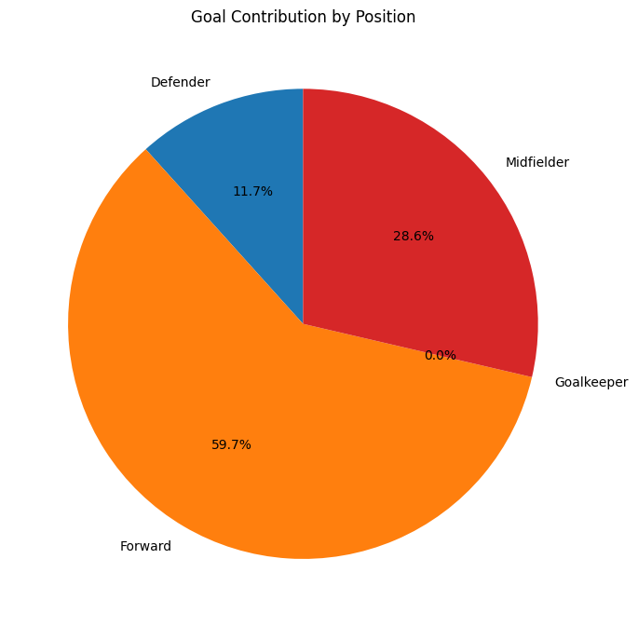
Interpretation:
The line chart displays variation in total goals among the top fifteen teams.
Algorithm 3 – Pie Chart
Step 1: Group the data by player position and calculate total goals for each position.
Step 2: Use the pie() function to represent the goal contribution of each position.
Step 3: Add position labels and percentage values using the autopct parameter.
Step 4: Set the starting angle and add a suitable title.
Step 5: Display the pie chart.
Program 4:
country_goals=df.groupby("team")["goals"].sum().nlargest(15); plt.figure(figsize=(10,5)); plt.plot(country_goals.index,country_goals.values,marker="o"); plt.title("Top 15 Teams by Total Goals"); plt.xlabel("Team"); plt.ylabel("Total Goals"); plt.xticks(rotation=45,ha="right"); plt.grid(True,alpha=.3); plt.tight_layout(); plt.show()
Output:
A pie chart titled “Goal Contribution by Position” showing the percentage contribution of each position.
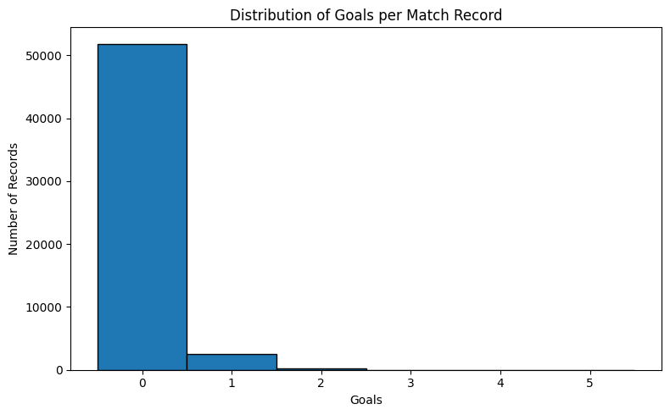
Interpretation:
The pie chart shows how goals are distributed across the different player positions.
Algorithm 4 – Histogram
Step 1: Select the goals column from the dataset.
Step 2: Create intervals using bins from 0 to 6.
Step 3: Use the hist() function to plot the frequency distribution of goals.
Step 4: Add the chart title, X-axis label, Y-axis label, and X-axis tick values.
Step 5: Display the histogram.
Program 5:
positions=df.groupby("position")["goals"].sum(); plt.figure(figsize=(7,7)); plt.pie(positions.values,labels=positions.index,autopct="%1.1f%%",startangle=90); plt.title("Goal Contribution by Position"); plt.tight_layout(); plt.show()
Output:
A histogram titled “Distribution of Goals per Match Record” showing the frequency of goal values.
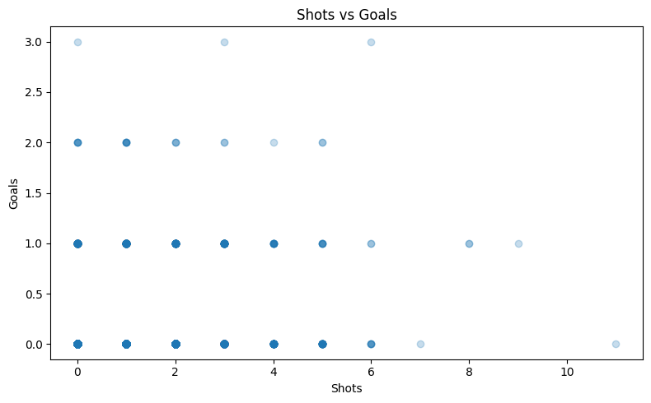
Interpretation:
The histogram helps identify the frequency of different goal values in the dataset.
Algorithm 5 – Scatter Plot
Step 1: Select a sample of 5000 records from the dataset using a fixed random state.
Step 2: Choose shots as the X-axis variable and goals as the Y-axis variable.
Step 3: Use the scatter() function to plot the sampled records.
Step 4: Add a title and suitable axis labels.
Step 5: Display the scatter plot.
Program 6:
plt.figure(figsize=(8,5)); plt.hist(df["goals"],bins=range(0,7),edgecolor="black",align="left"); plt.title("Distribution of Goals per Match Record"); plt.xlabel("Goals"); plt.ylabel("Number of Records"); plt.xticks(range(0,6)); plt.tight_layout(); plt.show()
Output:
A scatter plot titled “Shots vs Goals” showing the relationship between shots and goals.
Interpretation:
The scatter plot helps examine the relationship between the number of shots and goals.
Result
Thus, different data visualization techniques including a horizontal bar chart, line chart, pie chart, histogram, and scatter plot were created successfully using Matplotlib on the FIFA World Cup 2026 player performance dataset. The graphical outputs help in understanding player goal contributions, team goal totals, positional contributions, goal frequency, and the relationship between shots and goals.

